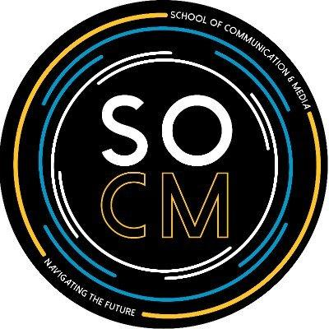

**Kennesaw State University School of Communication and Media**

**Contact Info: Est. 1996**

Kennesaw Campus Graduate Contact: Undergraduate Contact Info:

Social Sciences Bldg #402, Rm 5106 [comgradstudies@kennesaw.edu](mailto:comgradstudies@kennesaw.edu) socm@kennesaw.edu

(470) 578-4900 (470) 578-6298

**Mission**:

The School of Communication & Media at Kennesaw State University encourages students through their academic journey to shape them into effective, life-long communicators, pro-active leaders, and scholarly practitioners who create, design, deliver, and interpret the meaning of messages in interpersonal, organizational, and societal contexts. Our graduates will be prepared to actively contribute to the continuously evolving local and global communities while adapting to the constantly changing technological environment.

**What We have to Offer**: **Upcoming Highlights**:

* Digital Media Lab Radow College Dean's Lecture Series – March 03, 2022
* Georgia Film Academy Adobe Creative Jam Kicks Off with Record Registration- March 3, 2022
* Internships RCHSS Announces 2020-21 Grant Award Recipients – July 30, 2021
* Global Learning

**Undergraduate Programs**: **Faculty & Staff**: Kennesaw State

* B.S. in Journalism & Emerging Media University’s SOCM program has
* B.S. in Media & Entertainment more than 70 incredible faculty and
* B.S. in Organizational & Professional Communication staff that will encourage you through
* B.S. in Public Relations your academic journey. Please visit
* Minor in Crisis Preparedness our **Faculty & Staff** section on
* Minor in Public Relations website for more information.
* Minor in Organizational & Professional Communication

**Graduate Programs**:

* Master of Arts in Integrated Global Communication
* Graduate Certificate in Digital and Social Media
* Masters in Public Administration and Integrated Global Communication

**For more information on our program, please visit:** [**https://radow.kennesaw.edu/socm/**](https://radow.kennesaw.edu/socm/)

**# # #**

**Contact Info:**

**Cayman Handley** [**caymanhandley1@gmail.com**](mailto:caymanhandley1@gmail.com) **Last Updated: 4/5/2022**

**678-928-9328 chandle5@students.kennesaw.edu**